COMPUTER SCIENCE FUNDAMENTALS AND CAREER PATHWAYS

ASSIGNMENT 4

TOPIC: Build & Document a Mini Project Using GitHub and VS Code.

NAME: Dolare Shruti Manohar

ROLL NO: 2501730066

COURCE: BTech CSE (AI ML)

SECTION: C

STATIC PORTFOLIO WEBPAGE

Github repository link:

https://github.com/Shruti-codes27/CSFCP-assignment-4.git

Github link:

https://github.com/Shruti-codes27

I used Visual Studio Code to write my HTML and CSS code, and tested my webpage using the preview features.

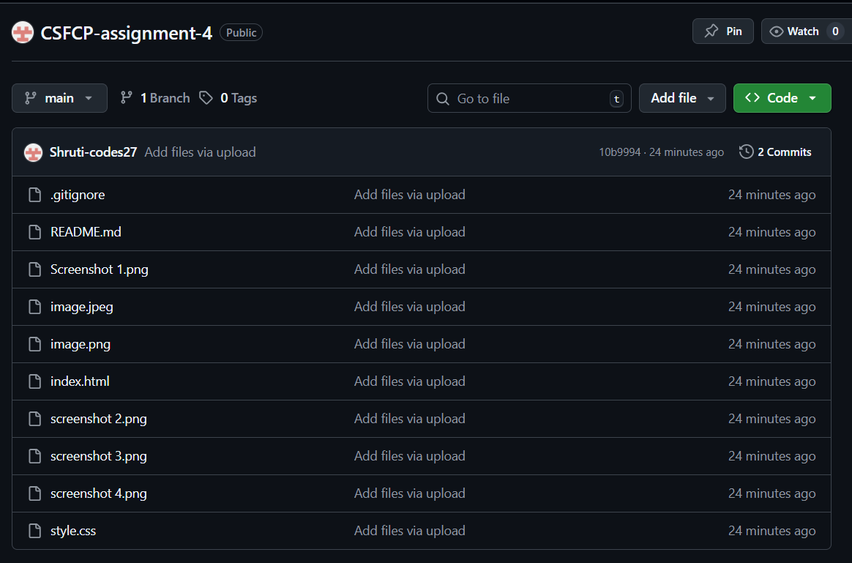

STATIC PORTFOLIO WEBPAGE

OUTPUT:

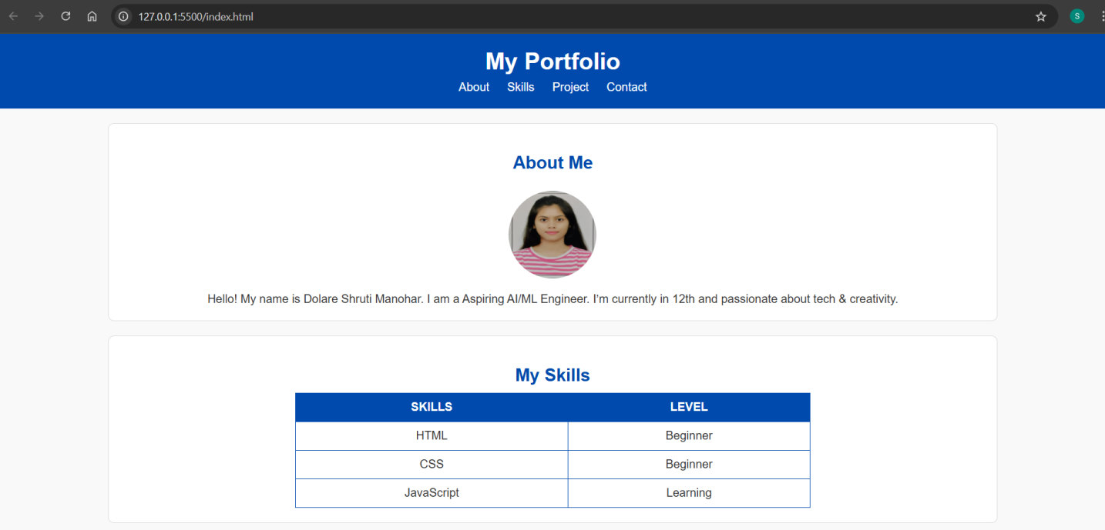
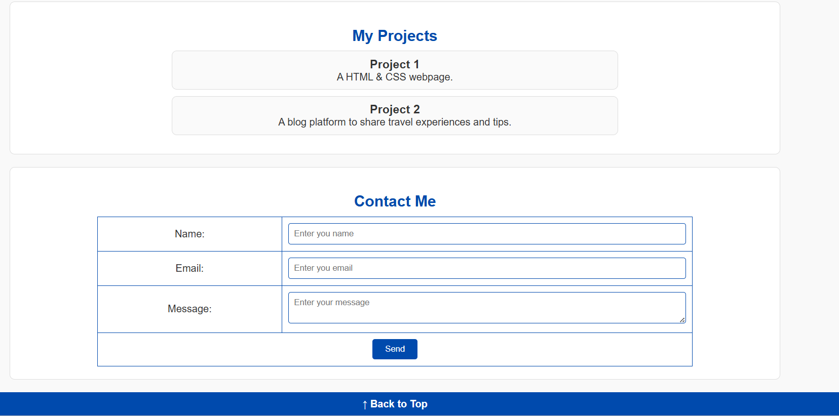

CODE:

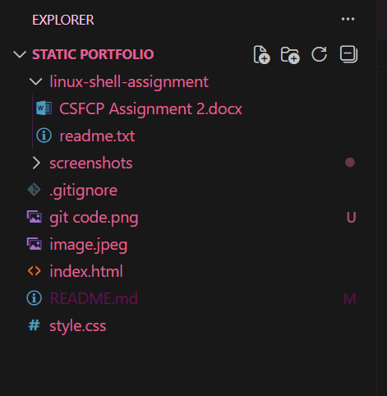

GIT COMMANDS:

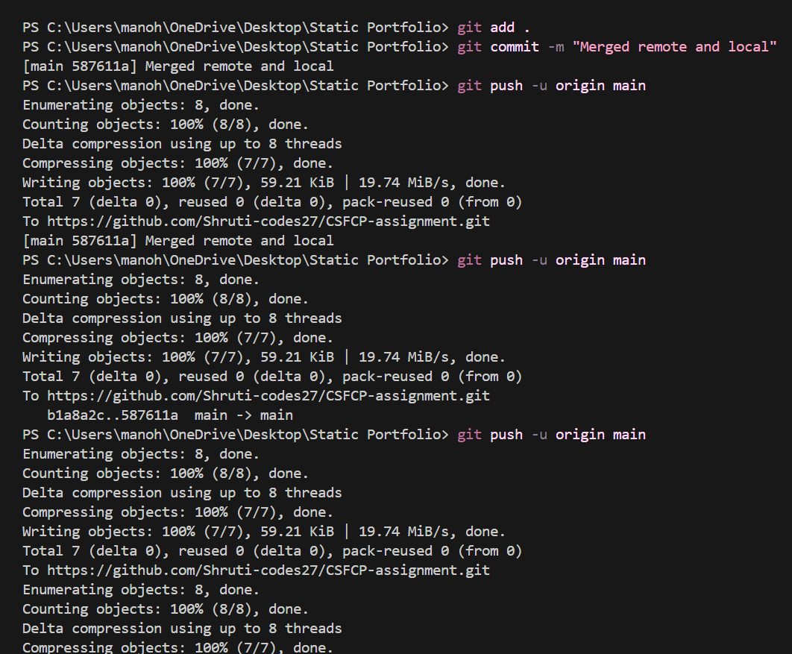

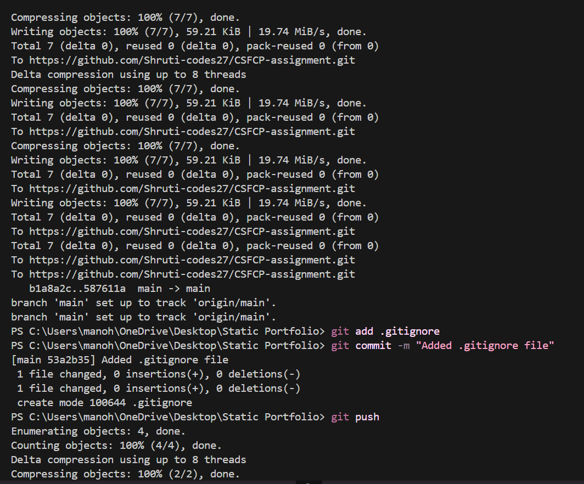

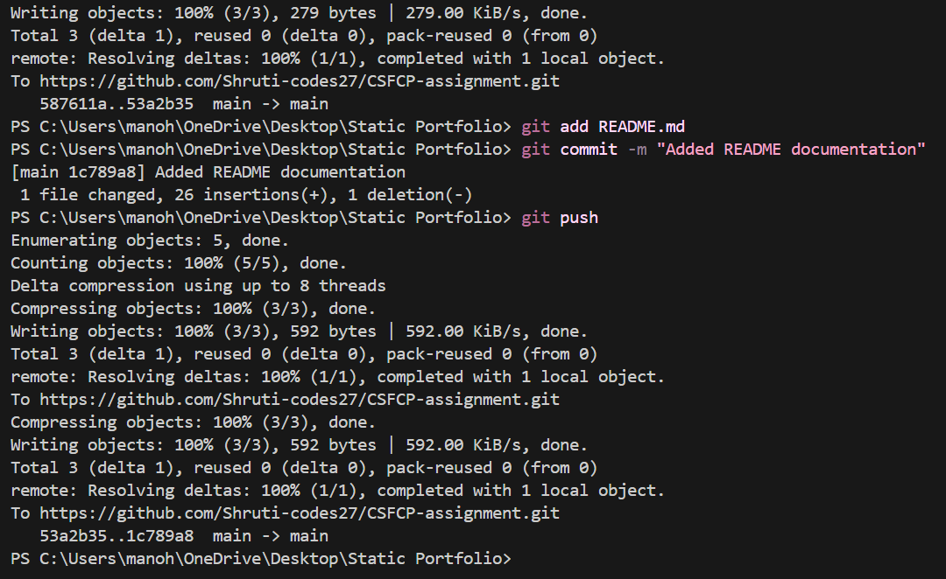

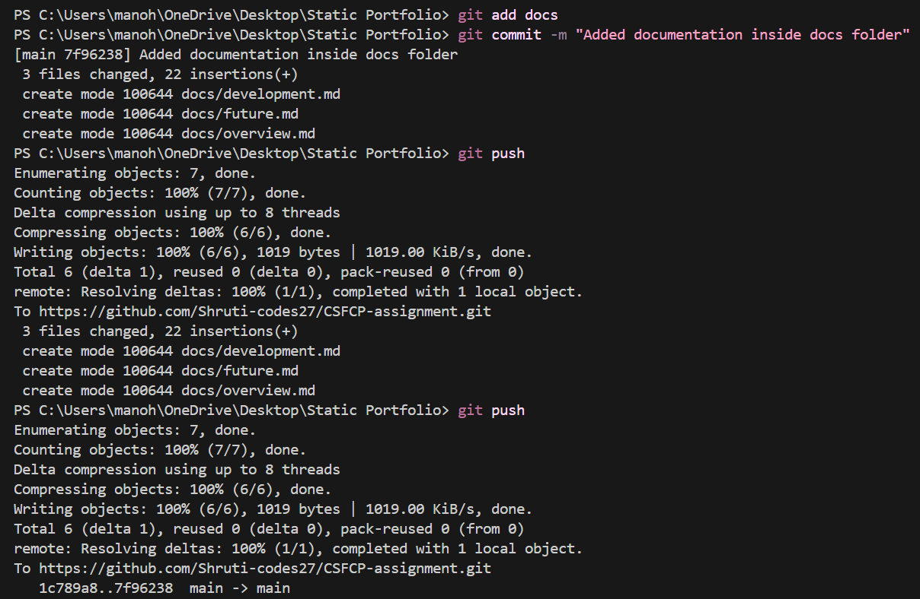

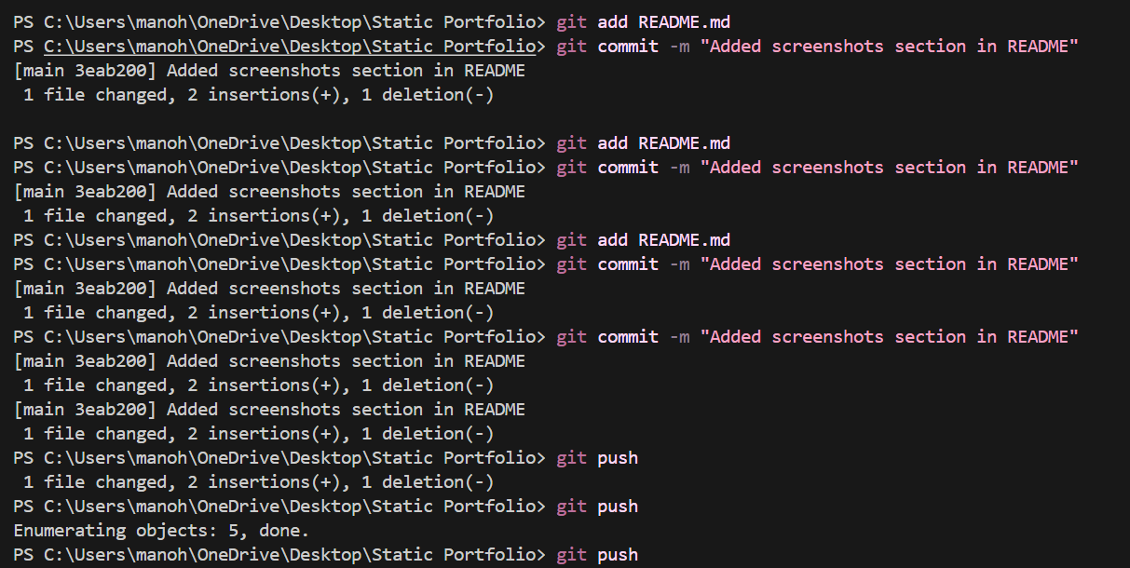

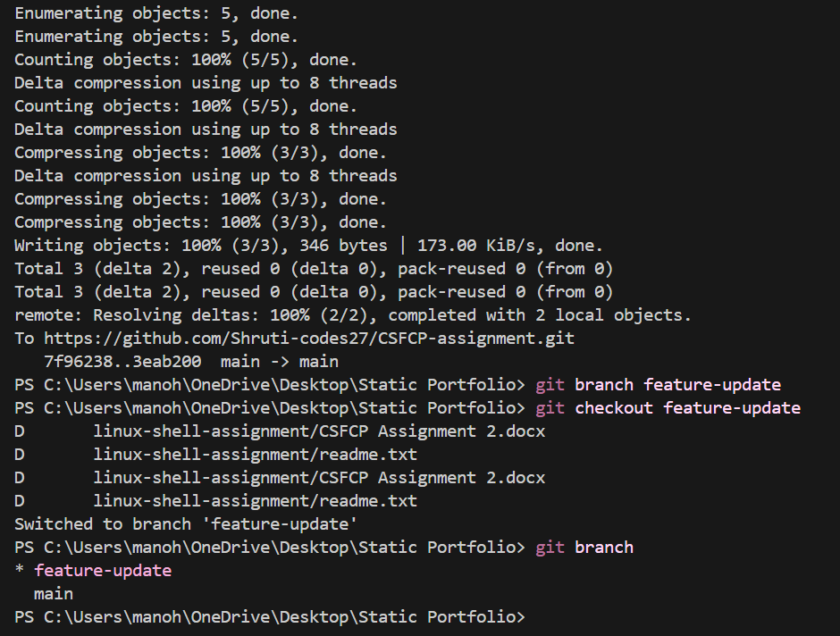

README.md:

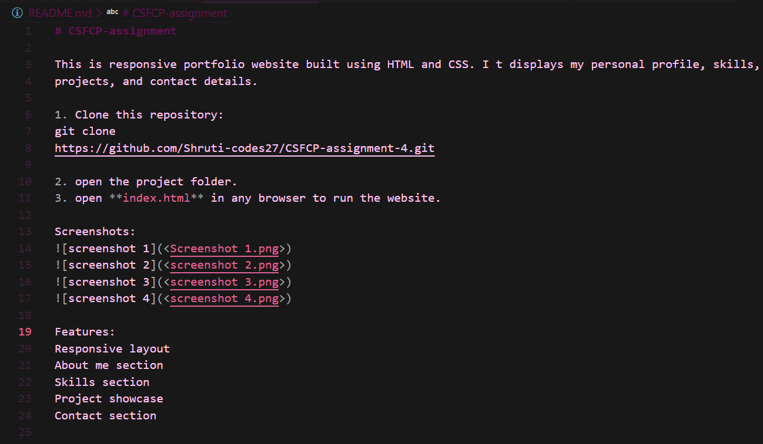

.gitignore:

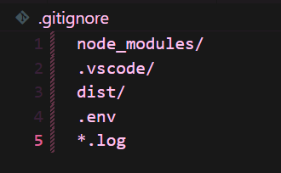

DOCS:

